1. Start **Jenkins.war** file on Command prompt using below code

**cd /d "D:\All_Automation_Projects\EndToEndIntegration_With_Jenkins_GIT_Maven\Softwares"**

**java -jar jenkins_2_107_3.war**

1. If it the first time running Jenkins then it will ask you to set the password.

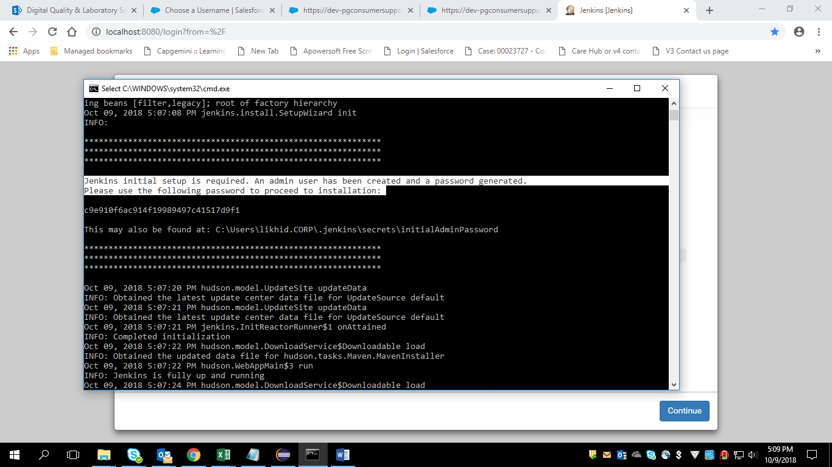

1. Open the below URL in the chrome browser

<http://localhost:8080/login>

It will display like below

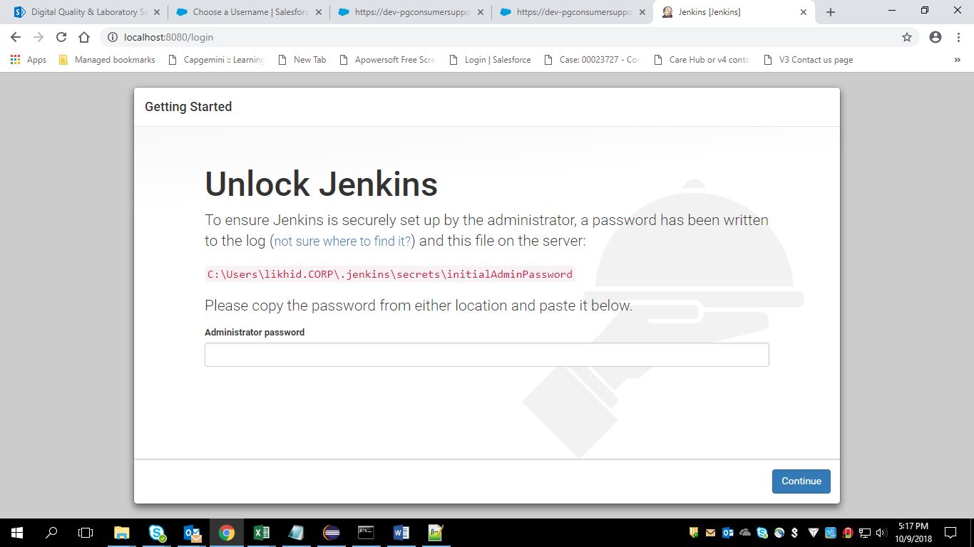

Go to the path mentioned on the display and then copy the password and paste it here

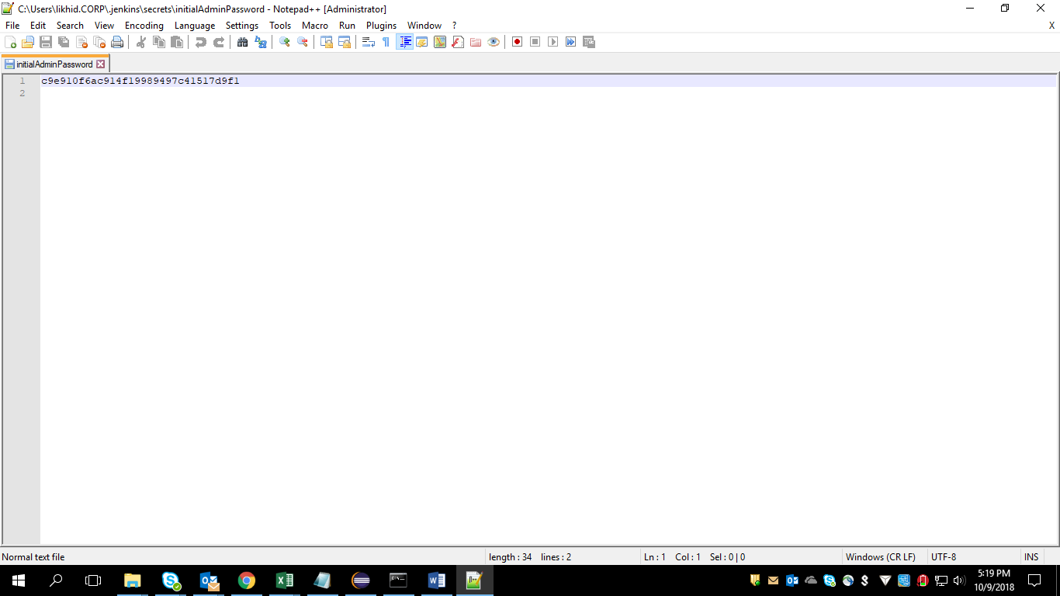

Note : This ‘InitialAdminPassword’ file will be present only if we are running the Jenkins for the first time. From the next time onwards (i.e.,once we set up the Jenkins ) this file won’t be there.

1. I have selected ‘Install Selected Plugins’ Option and it start downloading all plugins

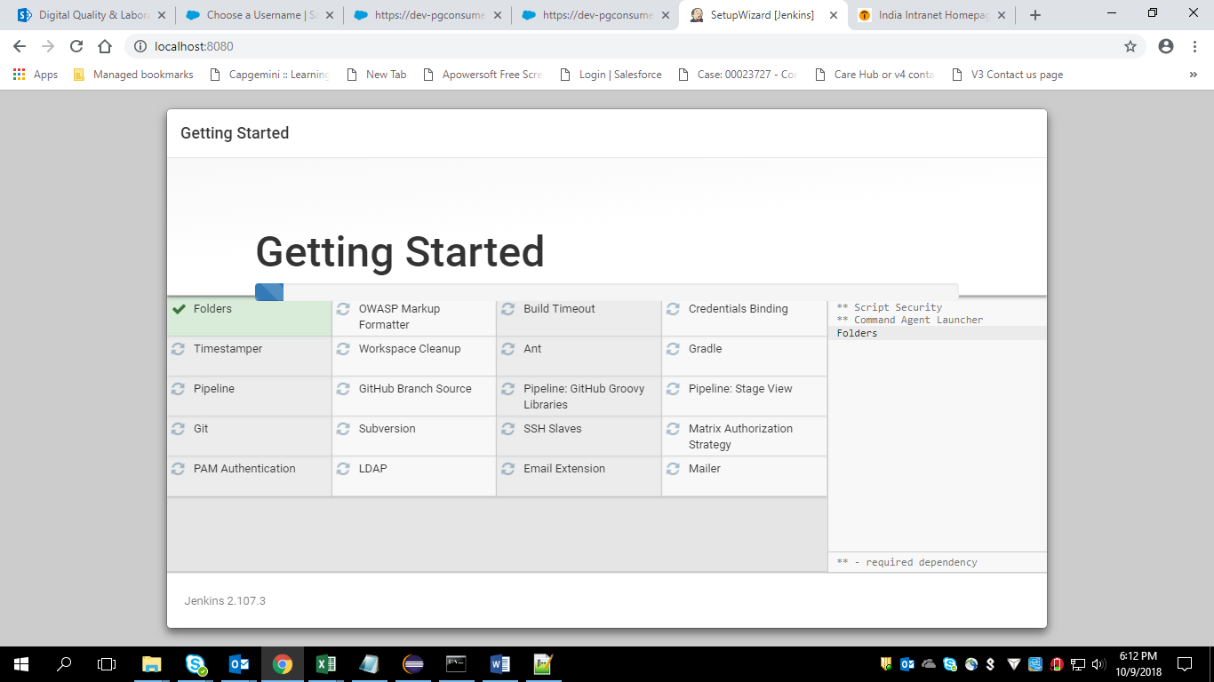

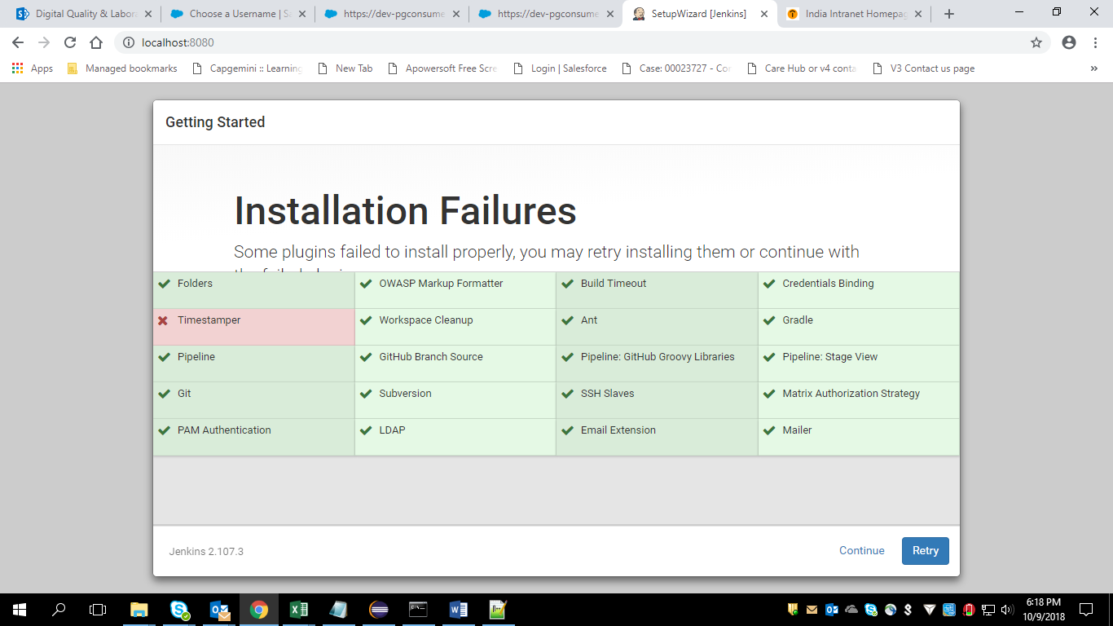

I have selected “Continue”

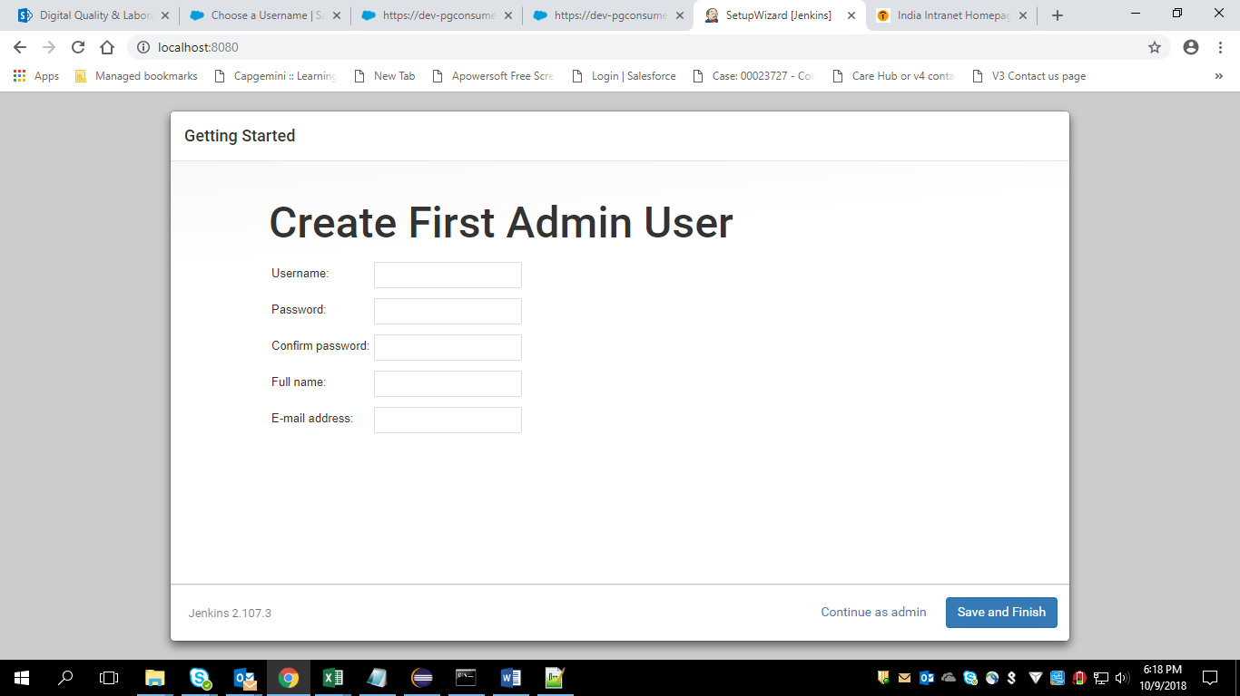

I need to create an admin user now by setting up my own password

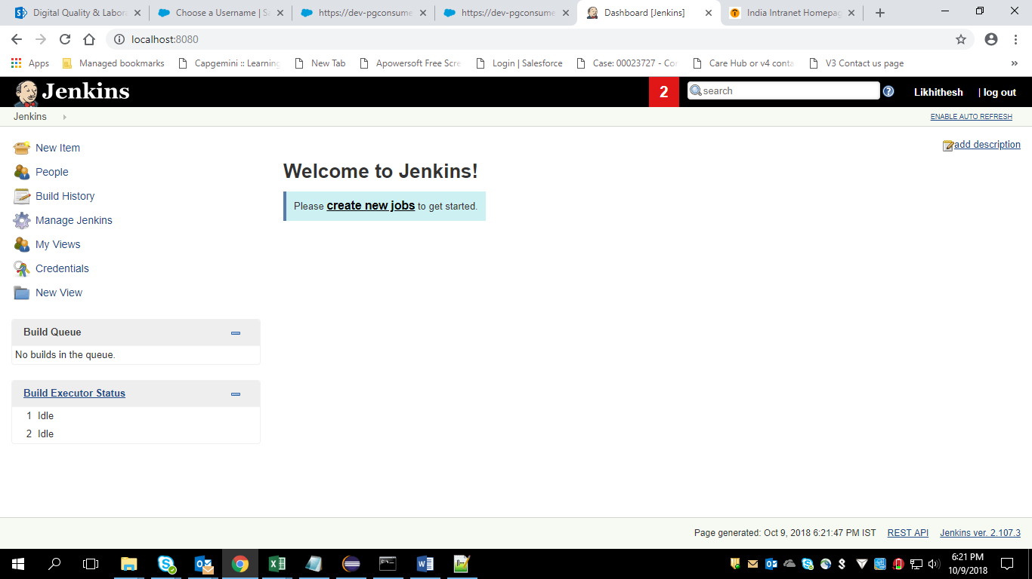

I have landed on Jenkins Home page.

**Imp Note :** When I reconfigure my system , Jenkins is gone and when I try to run the Jenkins asked me to do the things from the beginning i.e., from set up the password for admin user

**LL2)** If we want to do some password change or any other settings related to jenkins then we should use config.xml file in “C:\Users\likhid.CORP\.jenkins” path

**LL3)**